MANDATORY DISCLOSURE UPDATED ON: 02 January, 2018

AICTE FILE NO. : F.NO.WESTERN/2017/1-3377525821
Permanent Application ID : 1-3377525821
Date & period of approval : Approved for 2017-18

NAME & DETAILS OF THE INSTITUTION:

Name | Shri Vile Parle Kelavani Mandal’s Institute of Technology, Dhule
Address | Survey Number 499, Plot No. 02,Behind Gurudwara, Mumbai Agra Road, Dhule, Maharashtra-424001
District | Dhule
Pin Code | 424001
State | Maharashtra
STD Code | 02562 | Phone No: (02562)-297801, 297601
Fax No. | 02562-297801 | E-Mail: iotdhule@svkm.ac.in
Web site | www.svkm-iot.ac.in

Office Hours: 10 am to 5 pm
Type of Institution: Category 1: Unaided Private Affiliated College
Category 2: Minority- Gujarati Linguistics
Category 3: Co-education
Name of Organization: Shri Vile Parle Kelavani Mandal

Address of Organization:

SVKM New Building,10th Floor, (West Wing),V.L Mehta Road, Vile West,Mumbai-400056.

Registered with:

F-30(Bom), dated 07/04/1953(Under Bombay Public Trust Act 1950), 733 of 1934-35, dated 31/10/1934(Under Society’s Registration Act XXI of 1860)

Registration date: Registered Under Bombay Public Trust Act, 1950, on 07 /04/ 1953
Registered Under Society’s Registration Act XXI of 1860, on
31/10/1934
Website: www.svkm-iot.ac.in
Name of affiliating University: Dr. Babasaheb Ambedkar Technological (DBATU)
University Address: Dr. Babasaheb Ambedkar Technological University Vidyavihar, Lonere, Dist. Raigad - 402 103, Maharashtra.
Telephone No. : 02140 - 275081, 275212
Fax: 02140 - 275040, 275142
Website: http://dbatuonline.com/

Latest Affiliation period: Approved for A.Y. 2017-18

Name of the Affiliating University
Name | Dr. Babasaheb Ambedkar Technological University
Address | Vidyavihar, Lonere, Dist. Raigad - 402 103, Maharashtra.
Pin Code | 402103
STD Code | 02140 | Phone No. | 275081,275212
Fax No. | 02140 - 275040 | E-Mail | registrar@dbatu.ac.in
 |  | Web site | www.dbatu.ac.in

NAME & ADDRESS OF THE PRINCIPAL
Name | Dr. Nilesh P. Salunke
Designation | Principal | Qualification & Experience | Highest Degree | Specialization | Total  Experience
Designation | Principal | Qualification & Experience | Ph.D. | Thermal Engin eering | 13.6 years
STD Code | 02562 | Phone No. (O) 297801 | Fax No. | 02562-297801
STD Code | 02562 | Phone No. (R)297601 | Fax No.
E-Mail | Nilesh.salunke@svkm.ac.in |  | Mobile No. | 9881136769

Governing Body Members
- Members of the Board and their brief background

Following is list of members of Governing Body for Shri Vile Parle Kelavani Mandal’s Institute of Technology, Dhule as per Appendix 18 of AICTE Approval Process handbook 2016-17.

SN | Name of Member | Particulars | Nominee appointed  by | Details
1 | Shri. Amrishbhai R. Patel | Chairman | Nominated by  Society | Entrepreneur &  Industrialist
2 | Shri. Bhupeshbhai R. Patel | Member | Nominated by  Society | Entrepreneur &  Industrialist
3 | Shri. Rajgopal Bhandari | Member | Nominated by  Society | Entrepreneur &  Industrialist
4 | Dr. Jayant. P Gandhi | Member | Nominated by  Society | ENT Surgeon
5 | Shri. Harshad H. Shah | Member | Nominated by  Society | Entrepreneur
6 | Regional Officer, Western regional Office, AICTE, Mumbai | Member | Nominee of AICTE | Regional Officer AICTE
7 | An Industrialist / Technologist / Educationalist from the Region | Member | Nominated by  Regional Committee | An Industrialist /  Technologist / Educationalist
8 | Nominee of Affiliating University | Member | Nominated by University | Nominee of Affiliating University
10 | Nominee of State Government | Member | Nominated by DTE | Ex. Official
11 | Director of Institute | Member Secretary | Nominated by Society | Director
12 | Faculty of Institute | Member | Nominated by Society | Two Faculty of Institute
Date of Last meeting: Feb 03, 2017

Attendant

Nature and Extent of involvement of Faculty and Students in Academic affairs/ improvements
Faculty and students will be involved in department of good academic activities by forming various committees
  - Allocation of class teacher and local guardian (Teacher Student 1:15)
  - Extra coaching classes for weaker students by senior faculty (If required)
  - Special classes for top 10 students
  - Involvement in various activities like soft skills development, technical skill development, sports, cultural, paper presentation contests, any social activity by forming a committee with head as a teacher and members as a student.
  - Staff performance will be measured and improved by the student’s feedback and their suggestions.
  - Student’s performance will be measured by the teacher by conducting various tests and the suggestions given by the teacher.
  - Training course for the students will be conducted according to the demand received from the students.
Mechanism/Norms & Procedure for Democratic/Good Governance

Frequently academic activities, Finance Budget/utilization, staff performance, Student Performance, Grievances will be discussed by Governing body and remedial actions will be taken.

Philosophy of Governance
Introduction:- The management of SVKM believes in implementing fair and transparent management policies. It believes in taking all of the members into confidence before implementation of process and plans. Issues are discussed and agendas are placed during the Annual General Body meeting. It is made sure that any major decision enjoys the full unanimous support of the members without any conflict of ideologies or interests whatsoever.

Best practices and methodologies implemented in successful organizations are observed and discussed to find out its viability in the local environment with respect to SVKM.
A significant amount of emphasis is laid on bottom up communication where a considerable amount of feedback is obtained from the lower tiers of hierarchy and policies finalized for further action.
Although the duties and functions have been defined for each level of management and for each member within a particular level, provision is still made for acertain amount of autonomy. A member can exercise this power during exceptional circumstances in the larger interest of the organization. Such decisions are often appreciated by others in the hierarchy.
Participation:- Participation by both men and women is a key cornerstone of good governance. Participation could be either direct or through middle level management members. Management ensures that the participation is informed and organized. This implies freedom of association and expression on the one hand and an organized system on the other hand.

Rule of law:- Policies are implemented in view of legal frameworks which are enforced impartially. Full protection of human rights, particularly those of minorities are taken care of.

Transparency:- Fair amount of Transparency is maintained in all the decisions taken and their enforcement are done in a manner that follows rules and regulations. Information is freely available and directly accessible to those who will be affected by such decisions and their enforcement.

Responsiveness:- All the processes and decisions reach all those are involved in the system, within a reasonable timeframe.

Consensus oriented:- Conflicts in ideologies and interests are sorted out through mediation to reach a broad consensus in the larger interest of the organization and community.

Equity and inclusiveness:- The management imparts a sense of security and wellbeing to all of its members, faculty and students so that they do not feel excluded from the mainstream of organization. This is achieved by providing all groups, the opportunities to improve or maintain their wellbeing.

Effectiveness and efficiency:- Management ensures that the processes and institution produce results that meet the needs of industry and society while making the best use of resources at their disposal. This includes sustainable use of natural, human and financial resources and the protection of the environment.

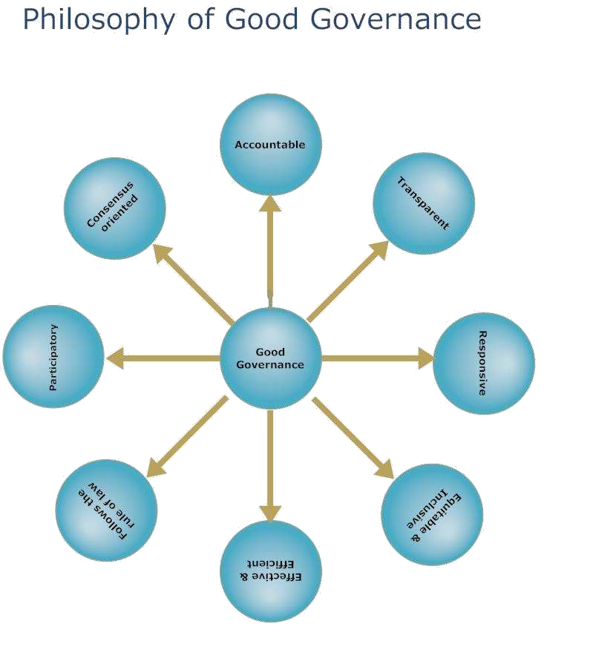

- Student Feedback on Institutional Governance/Faculty Performance.

SHRI VILE PARLE KELAVANI MANDAL’S INSTITUTE OF TECHNOLOGY, DHULE (DEPARTMENT )

The objective of this form is to obtain feedback from students in order to assist the faculty to diagnose the shortfalls so as to make the process of Teaching-Learning more effective.
Against every item of response, a box is provided to fill the appropriate marks out of 5, where 5 stands for best and 1 stands for poor.

Course
EVALUATION OF TEACHERS BY STUDENTS

Name of Faculty Date of Feedback

Your Rank in Class – Among top 25% Among top 50% Others

SR. NO. | Item of Response | Rating (Out of Highest 5)
1 | Teacher comes to class on time
2 | Teacher is well prepared
3 | Aims and objective made clear
4 | Subject matter organized in a logical sequence
5 | Command over English
6 | Class management
7 | Completion of syllabus
8 | Depth of coverage
9 | Explanation power
10 | Notes and dictation are clear and effective
11 | Did you feel encouraged to ask questions
12 | Did the process make you think?
13 | Did you feel motivated to learn more
14 | Teacher offers assistance and counselling as and when needed by you
15 | Does the teacher answer the questions raised by you to your expectation?

Any other comments :

QUESTIONNAIRE FOR ASSESSMENT Feedback
Note: Please tick as √ in front of your appropriate choice/feelings (mark once)
Gender |  | Male |  |  | Female
BE aggregate % (Tick any one)
% | 100-85 | 84-74 | 73-64 | 63-55 | 54-47 | 46-40
Grade | A+ | A | B | C | D | E
[A] Teaching Learning  (in terms of learning support and academic) |  | Excellent | Good | Average | Fair | Poor
Credit System
Utilization of Teaching Aids
Conference and Workshop Conducted
Library Facility (Books and journals available)
Internet and Wi-fi facility
Guest Lectures conducted
Industrial/Education/Field tour arranged
Use of latest technology
Innovative practices
Faculty Support
Syllabus and Course Contents
Examination System
Studious Environment
Paper presentation/Project presentation Encouragement
[B] Infrastructure  (in terms of comfort, aesthetic and use of latest technology) |  | Excellent | Good | Average | Fair | Poor
Building
Class Room Comfort with Audio-Visual facility
Laboratory Equipment
Sports
Cultural
Hostel
Canteen
Library
Computer Lab / Center
Sanitary

[C] College Promotional Activity | Excellent | Good |  | Average | Fair | Poor
Website
Print Media Advertisement/News
Hoarding and Banners
Brochure / booklets / Leaflets
Educat
ion Fairs / Event Sponsorships

[D] Student’s Support System | Excellent | Good | Average | Fair | Poor
Local Guardian & Counselling system
Soft Skill Training Courses
Technical Training Courses
Placement Assistance
Higher Education Guidance
Safety and Security
Health care and Gym
College Canteen and Mess/Food
Hostel facility
Hostel Canteen and Mess/Food
Hostel Discipline and Environment
Indoor and Outdoor game facility
Cultural Activity
Administrative/Office Support (in terms of time consumed for
processing of your request)
Department Support (in terms of time consumed for processing of
your request)
Library (in terms of Books / Journals available and time
consumed for processing of your request)
Scholarship/Freeship & Financial Aids support
Student Reward and Award (appreciation)
Anti-Ragging Environment (Ragging-Free)
Bus Transportation
[E] Others | Excellent | Good | Average | Fair | Poor
Brand Image & Management Reputation
Campus overall Life and Culture

[F] What you achieved (gain)?  (Rate your development in last 3 / 4 yrs, studying in  Technical/Professional Education) | Excellent | Good | Average | Fair | Poor
General Knowledge
Technical Skills (Special Course/program)
Soft Skills (English Proficiency, Communication, Aptitude, Body
Language, behavioral style)
Group/Friend Development
Social & Humanity
Leadership
Self-Confidence Level
Emotional Stability
Pressure/Stress Handling ability
Creativity / Idea Generation
Ability to achieve Goals/Objectives

- Grievance Redressal Mechanism for Faculty, Staff and Students

Staff Grievance Committee | Students Grievance Committee
All Grievance dispute will be solved by Grievance committee for student/staff constitution of Grievance committee is as follow
- Chairman  - Principal  - HODs | - Principal  - Staff  - Students
- PROGRAMMES
  - Name of the Programmes approved by AICTE (New Institution):

Proposed Courses | Proposed Intake
Computer Engineering | 60
Information Technology | 60
Mechanical Engineering | 60
Civil Engineering | 60
Electrical Engineering | 60
  - For each Programme the following details are to be given:

Name of Course | No. of Seats  2008-09 | Duration | Cut off Marks
Information Technology | 60 | Four Years | As per CET Score for first year.
Computer Engineering | 60 | Four Years | As per CET Score for first year.
Mechanical Engineering | 60 | Four Years | As per CET Score for first year.
Electrical Engineering | 60 | Four Years | As per CET Score for first year.
Civil Engineering | 60 | Four Years | As per CET Score for first year.

Fee Structure 2017-18
Fees structure stated by Shikshan Shulk Samiti, Mumbai and State Govt. of Maharashtra.

Placement Facilities

The Placement cell will be constituted by the members Training and Placement Officer as a head and staff and students conducts various kinds of training program on English Speaking, Personality Development Skills and Interview Techniques which helps to be trained practically horn their skills according to the market demand. The Cell will also organize frequent industrial visits for students.

Campus placement in last three years with minimum salary, maximum salary and average salary

S.No. | Year | Minimum Salary  Offered (Gross) pm | Maximum Salary  Offered (Gross) pm | Average Salary  Offered (Gross) pm
Not Applicable as the Institute is new

  - Name and duration of programme(s) having affiliation/collaboration with Foreign University(s)/Institution(s) and being run in the same Campus along with status of their AICTE approval. If there is foreign collaboration, give the following details:

Nil

- PROFILE OF DIRECTOR/PRINCIPAL WITH QUALIFICATIONS, TOTAL EXPERIENCE, AGE AND DURATION OF EMPLOYMENT AT THE INSTITUTE CONCERNED
Please visit to Faculty details page for information.

- FEES
Will be charged as per SSS, Mumbai norms.

- ADMISSION
  - Number of seats sanctioned with the year of approval. NA

  - Number of students admitted under various categories each year in the last three years.
NA
Sr. No. | Branch | Students Admitted
1 | Information Technology | 03
2 | Computer Engineering | 47
3 | Mechanical Engineering | 39
4 | Electrical Engineering | 11
5 | Civil Engineering | 47
  - Number of applications received during last two years for admission under Management Quota and number admitted.
NA

Admission Procedure
For the eligibility and admission process for the admission to the First Year Engineering.
www.dtemaharashtra.gov.in
and http://dbatuonline.com/

Counseling / Mentoring Student Counsellor & Local Guardian Scheme-
Local Guardian will be allotted to group of the students who help them in all their problems including issues like academic, financial concerns, accommodation, faculty interaction etc. He will conduct periodic meetings with students to help them in their personal and curricular problems. He will assist them for Activities -anything that impacts on success of students
Clarify policies and procedures Share personal concerns Discuss academic problems
Review study and time-management skills

Career Counseling Through Training & Placement Cell
A separate Training & Placement Cell will be formed with dedicated staff. It provides students training programs to enhance their technical/ non-technical skills & for career development

Medical Facilities Available
Institute have Medical staff to provide first-aid and medical help in emergency. Physical Teacher will be also trained to give First-Aid Treatment. Institute has Medical Center which is well equipped with First-Aid facility. Medical practitioners from outside will visit the institute in the afternoon daily.

Student Insurance Available

Student Activity Body Will be formed after academic commencement
Cultural activities Annual Social Gathering, Fresher’s Party, Engineering Day celebration
every year Special focus will be given for all round growth of students by encouraging them to participate in extra- curricular and co-curricular activities. Every year the Institute will conduct co-curricular activities like Essay, Debate, Quiz, Song, Music Competitions and the winners will be awarded during the Annual Day.

Sports Activities Sports Week will be held every semester.

Literary Activities 1) One hour every week (on Wednesdays) for literary and cultural activities.
- Encouragement and guidance for participation in Inter College Competitions.
- Encouragement and guidance to speak from public platforms.
- Programmes by eminent artists and speakers.
- Manuscript magazines and printed College Annual to bring out the hidden literary talents.

Magazine/Newsletter One issue of Technical Magazine will be published in each semester which will consist of articles & information of current trends in the field of Engineering.
Technical activities/ Techfest Tech fest (technical symposium) will be organized every year which will consist of various competitions such as poster & paper presentation, project/ Model presentation, Debate & quiz Competition, circuit / PCB design competition.
Industrial Visits Will be arranged yearly (Visit to Mobile Main control station, Fully automated Industries such as spinning mill, Telephone Exchange station, Software Industries)
Alumni Activities Alumni meet will be arranged frequently. The College will have an Alumni Association.

Officer for RTI
Principal of Shri Vile Parle Kelavani Mandal’s Institute of Technology, Dhule

Designation Principal

Contact Details
Phone no with STD code 02562-297801
Fax no with STD code 02562-297801

Eligibility conditions and requirements for admissions
(1) Maharashtra State Candidature Candidate.-
(i) The Candidate should be an Indian National;
(ii) Passed HSC or its equivalent examination with Physics and Mathematics as compulsory subjects along with one of the Chemistry or Biotechnology or Biology or Technical or Vocational subjects, and obtained at least 50% marks (at least 45% marks, in case of Backward class categories and Persons with Disability candidates belonging to Maharashtra State only) in the above subjects taken together; and obtained score in CET conducted by the Competent Authority.
Or
(ii) Passed Diploma in Engineering and Technology and obtained at least 50% marks (at least 45% marks, in case of Backward class categories and Persons with Disability candidates belonging to Maharashtra State only);
Or
ii) Passed B.Sc. Degree from a Recognised University as defined by UGC and obtained at least 50% marks (at least 45% marks, in case of Backward class categories and Persons with Disability candidates belonging to Maharashtra State only) and passed XII standard with Mathematics as a subject.
(2) All India Candidature Candidates, Jammu and Kashmir Migrant Candidature Candidates.-
(i) The Candidate should be an Indian National;
(ii) Passed HSC or its equivalent examination with Physics and Mathematics as compulsory subjects along with one of the Chemistry or Biotechnology or Biology or Technical or Vocational subjects and obtained at least 50% marks (at least 45% marks, in case of Backward class categories and Persons with Disability candidates belonging to Maharashtra State only) in the above subjects taken together and obtained score in JEE Main Paper I or in CET conducted by the Competent Authority;
Or
(ii) Passed Diploma in Engineering and Technology and obtained at least 50% marks (at least 45% marks, in case of Backward class categories and Persons with Disability candidates belonging to Maharashtra State only); Or ii) Passed B.Sc. Degree from a Recognised University as defined by University Grants Commission and obtained at least 50% marks (at least 45% marks, in case of Backward class categories and Persons with Disability candidates belonging to Maharashtra State only) and passed XII standard with Mathematics as a subject.
(3) NRI / OCI / PIO, Children of Indian workers in the Gulf countries, Foreign National.- The candidate should have passed the HSC or its equivalent examination with Physics and Mathematics as compulsory subjects along with one of the Chemistry or Biotechnology or Biology or Technical or Vocational subjects, and obtained at least 50% marks in the above subjects taken together;
Direct Second Year
- For Maharashtra State Candidature Candidate and All India Candidature Candidate,- (i) The Candidate should be an Indian National;
(ii) Passed Diploma Course in Engineering and Technology with at least 45% marks (40% marks in case of candidates of backward class categories and Persons with Disability belonging to Maharashtra State only) in appropriate branch of Engineering and Technology from an All India Council for Technical Education or Central or State Government approved Institution or its equivalent;
Or
(ii) Passed B.Sc. Degree from a University Grants Commission (UGC) or Association of Indian Universities recognized University with at least 45% marks (40% in case of candidates of backward class categories and Persons with Disability belonging to Maharashtra State only) and passed HSC with Mathematics as a subject. Provided that students belonging to this category shall clear the subjects of Engineering Graphics/ Engineering Drawing and Engineering Mechanics of the first year Engineering Program along with second year subjects.

Concession Scheme Details (As per Government of Maharashtra & National Scholarship Scheme )

Sr. No. | Category | Income | Apply Scheme | Form Fill Scheme
1 | ST (Scholarship) | Upto 1 Lakh | Tribal Development | Government of India Post-Matric Scholarship
2 | ST (Freeship) | Above 1 Lakh | Tribal Development | Tuition Exam Fee (Freeship)
3 | SC (Scholarship) | Upto 1 Lakh | Social Justice & Special Assistance | Government of India Post-Matric Scholarship
4 | SC (Freeship) | Above 1 Lakh | Social Justice & Special Assistance | Post-Matric Tuition Fee and Examination Fee
5 | OBC/VJ/NT/SBC (Scholarship) | Upto 1 Lakh | Social Justice & Special Assistance | Government of India Post-Matric Scholarship
6 | OBC/VJ/NT/SBC (Freeship) | 1 Lakh to 8 Lakh | Social Justice & Special Assistance | Post-Matric Tuition Fee and Examination Fee
7 | EBC (OPEN) | Upto 2.5 Lakh | Higher & Technical Education | Rajarshi Chhatrapati Shau Maharaj Shikshan Shulk Shishyavrutti Yojna
8 | EBC (OPEN) | 2.5 Lakh to 6 Lakh  (60% or more in SSC to last year) | Higher & Technical Education | Rajarshi Chhatrapati Shau Maharaj Shikshan Shulk Shishyavrutti Yojna

